(Approx. 1018 words)

MailWasher Free — Version 7.7
Free e-mail filtering software for Windows
Software review by John Langill, Newsletter Editor, Southern Tier Personal Computer Club
December 2015 issue, Rare Bits
http://www.pageorama.com/?p=stpcc1979
jlangil1 (at) stny.rr.com

Publisher: Firetrust - www.Mailwasher.com
Current Free Version: 7.7 (Pro Version also 7.7)
Supported Operating Systems: Windows XP, Vista, 7, and 8 (10? – see article)
Download: MailWasher (Free) - www.mailwasher.net/

MailWasher is e-mail filtering software for Windows that can detect and delete spam from a user’s e-mail while it remains on the e-mail provider’s server; that is, BEFORE it is downloaded to the user’s computer. This approach is what makes MailWasher unique among similar competitive products.

MailWasher uses a combination of user-defined filters, spam databases, and Bayesian filtering. The filters work on a small portion of each e-mail, and then allow unwanted e-mails to be directly deleted from the user’s POP3 inbox without them being downloaded to the e-mail client on the user’s computer. This approach prevents the downloading of spam and other messages infected with malware.

Through the use of a Bayesian filter, the more MailWasher is used the more the program’s spam detection capabilities improve. By marking certain e-mail messages as spam, the user trains this filter to detect spam more effectively in the future. For example, once MailWasher’s Bayesian filter learns that most messages containing the word “Drugs” are spam, it will automatically classify e-mails that use the word excessively as spam in the future.

MailWasher is available in two versions... Free and Pro. I’ll get to the main distinctions between the two versions a little later.

MailWasher debuted in 2001 and has been continually updated and enhanced ever since. I’ve been using the free version of MailWasher for well over a decade and I can say — thankfully — that I’ve never experienced having a PC infected by malware transmitted via e-mail in all that time — knock on wood.

Admittedly, it has required some diligence on my part; but MailWasher has made the task a lot easier by enabling me to filter out the spam e-mail without having it downloaded to my computer.
There are any number of programs that purport to automatically filter e-mail and remove spam; and they may do a fair job. While MailWasher can and does do much the same, it gives the user more “hands on” control by displaying e-mail waiting on the e-mail provider’s server; thus enabling the deletion of any suspicious or unwanted e-mail from the user’s inbox prior to downloading it to the e-mail client on the user’s computer. As a person who believes in the adage “If you want something done right, do it yourself,” I appreciate the direct control MailWasher gives me to categorize e-mail that is sent to me as coming from “friend” or “foe” as well as to set up MailWasher to recognize and delete e-mail from specific senders or domains even though it adds an extra manual step to the process of receiving e-mail.

The free version of MailWasher offers many customizing options; the Pro version even more. The screen-shot below illustrates how I’ve chosen to display e-mail messages waiting for me on the e-mail provider’s server and how they might be categorized. Note that two e-mail messages were automatically classified as spam and check-marked for deletion when MailWasher’s main screen was displayed. Any other messages, including those classified “Good” and “Friend,” may be check-marked manually. Any checked messages can also be un-checked. Clicking the “Wash Mail” button causes the checked messages to be immediately deleted from the e-mail provider’s server. Clicking the Thunderbird button brings up my default e-mail client to which the remaining messages on the e-mail provider’s server can be downloaded to my Inbox.

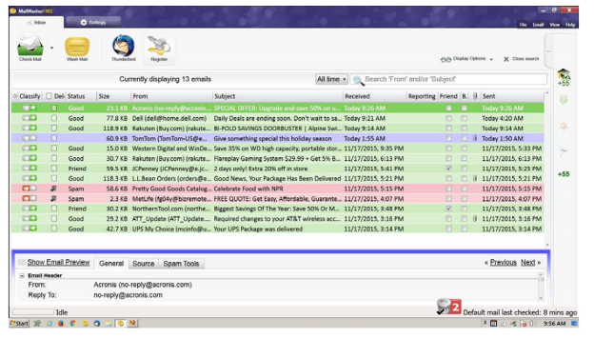

MailWasher Features

User Friendly
MailWasher is quick to install and easy to learn. MailWasher’s extensive Help fully explains the use of the many options and the methods of marking e-mail for various actions — deleting, reporting spam, even returning spam to senders — thereby training the software to differentiate between spam and good e-mail.

As with any such anti-spam program, however, MailWasher does not detect the presence of malware; e.g., fraudulent links, etc., that may be imbedded within an e-mail. That the user must still do through diligent observation of the content of an e-mail that has been downloaded to his or her e-mail client’s inbox.

E-mail Compatibility
The software works on all e-mail platforms, whether these are Web-based, POP, or IMAP servers. These include the most common e-mail hosts such as Microsoft Outlook, Outlook Express, Thunderbird, Windows Live Mail, Gmail, Hotmail, Incredimail, AOL, Postbox, Outlook.com, and Yahoo with Mail+.

Supported Operating Systems
MailWasher supports the following Windows operating systems: • Windows 8 and 8.1
• Windows 7 • Windows Vista • Windows XP. According to Firetrust’s website
MailWasher Pro 7.7 has been tested with Windows 10 and no issues were found. However, I have been unable to verify if the most recent version of MailWasher Free works with Windows 10 as well; but you can download and install the free version to see if it does.

Free vs Pro
The adjacent chart differentiates the features found in the two versions. Except for one year during which I tried the Pro version, I have found that the free version of MailWasher serves my needs well. I use only one e-mail address (account) and, except for an occasional oops, I found the Recycle Bin feature to be of little use — that’s not to say that I haven’t sometimes wished to have had it available.

In addition to what is shown in the chart, MailWasher Pro now includes mobility support for iPhone and Android devices.

Summary
There’s no question that e-mail remains the number one method for the distribution of malware with the potential to infect a user’s computer. A major headache among all e-mail users alike, phishing e-mails, junk e-mails, unwanted newsletters, and such, continue to clog inboxes and slow down server performance by unnecessarily taking up capacity. By structuring MailWasher around removing security threats before e-mails even reach user servers, the software ensures only wanted e-mail makes it to a user’s computer and learns quickly to adapt to the individual recipient’s preferences.

